**Date**: March 28, 2019

**To**: Emiliano Escobedo, Executive Director, HASS Avocado Board

**From**: Julian Vazquez and Michael Gregory, Junior Data Analysts, Janzen Consulting Group

**RE**: Average avocado price in 2015 vs 2018

Over the past decade, avocados’ popularity has risen to become one of Americans’ fruits of choice. According to the HASS Avocado Board, the demand for avocados has been constantly increasing since 2000[1], and does not show any signs of stopping any time soon. Because of this trend, we thought the HASS Avocado Board would be interested in our analysis on the average unit price of avocados in 2015 compared to 2018.

We hypothesize that the average price of our target population, Hass avocados in the US, was higher in 2015 than in 2018. We think this is the case because of the avocado shortage that the US experienced between 2015 and 2017[2], which would have caused the unit price of avocados’ nationwide to rise. Our findings will show that the average unit price of avocados was in fact higher in 2015.

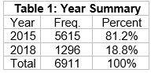We obtained the data for this study from the “Avocado Prices 2015 - 2018**”** dataset from the HASS Avocado Board. The dependent variable we utilized was the average price of avocados (per unit), and our independent variable was year (2015 & 2018). We created subsets of the data to only include the years 2015 and 2018 in order easily be able to conduct our analysis.

Based on our analysis, our independent samples t-test with an alpha of 0.05 reveals that our findings are statistically significant, t(2289) = 2.84, p < 0.01. The Cohen’s D effect size is 0.07, which is very small. Our one-tailed t-test shows that the difference in means is greater than zero, which is why we can safely reject the null hypothesis that stated no difference between the means.

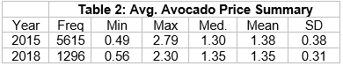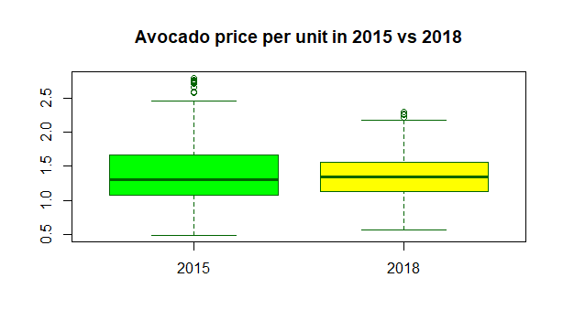One very important

limitation of this study is that, while the data set contains data for the entire year of 2015, it only encompasses January-March data for 2018. In order to solve this issue, another study would have to be conducted with the complete data for 2018. Another limitation is the fact that the data set used for our analysis only contains data from a carefully selected 55 regions in which Hass avocado prices tend to be lower than the national average. Because of this, our sample data is not representative of the Hass avocado prices in the US, which is why we cannot generalize our findings to the target population. The fix for this would be as simple as using a sample that is representative of the entire US. Overall, even though the average price of avocados in 2015 was higher than in 2018, the difference in means was < .03, which makes sense given the very small effect size. In the context of pricing this is not very meaningful.

1. Ferdman, R.A. (2015). The rise of avocado, America’s new favorite fruit. The Washington Post. Retrieved from <https://www.washingtonpost.com/news/wonk/wp/2015/01/22/the-sudden-rise-of-the-avocado-americas-new-favorite-fruit/?noredirect=on&utm_term=.a6f1e2dc50b1>
2. Cheng, L. (2014). An Avocado Shortage May Be On The Horizon, So Enjoy Your Guacamole While You Can. Bustle. Retrieved from <https://www.bustle.com/articles/52673-an-avocado-shortage-may-be-on-the-horizon-so-enjoy-your-guacamole-while-you-can>